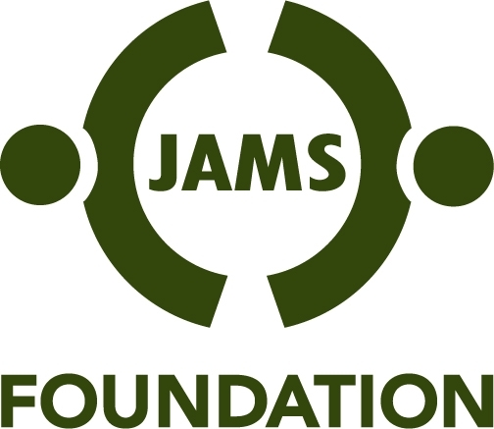

Weinstein International Fellowship

The Weinstein International Fellowship program, inaugurated in 2008, provides opportunities for individuals from outside of the United States to visit the U.S. to learn more about dispute resolution processes and practice and to pursue a project of their own design that serves to advance the resolution of disputes in their home country.

The JAMS Foundation Board of Directors will approve up to two Fellowships per year, providing up to $25,000 per Fellow in support of the project described in their application. The program is intended to be flexible and open to innovation, and Fellowship applicants are encouraged to be creative in developing projects/proposals that will increase the availability of dispute resolution education, training and services in their own countries and beyond.

During their time in the U.S., Fellows may be based in a JAMS Resolution Center or may participate in a university program or be connected to another organization or institution, depending on the nature of their project. Fellowships may be up to six months in duration.

It is anticipated that a Fellow will come from a country that does not have an established culture of using mediation for cases in litigation. Part of the Fellow’s time in the United States will be spent observing how JAMS administers and resolves such cases.

Criteria

1. Up to two Fellowships per year
2. Up to $25,000 per Fellowship
3. No more than six months in duration
4. Applicants must be fluent in English
5. Preference for proposals that would help other countries establish viable dispute resolution systems or change how disputes are resolved
6. Preference for applicants who have experience as judges, lawyers, court administrators or law professors.

Information sought from applicant

1. Purpose and goal of Fellowship
2. Educational background
3. Dispute resolution training or experience
4. Amount of funding sought and proposed use of funds
5. Other sources of funding available, applied for, or awarded
6. Organizations or institutions with which you are affiliated in your home country
7. Organizations or institutions with which you expect to work while in the U.S.
8. Other than financial support, additional resources or support that you would require from the JAMS Foundation
9. For non-U.S. applicants: whether you have or will you be able to obtain a visa for entry
into the U.S.
10.Where in the U.S you would like to base your Fellowship

