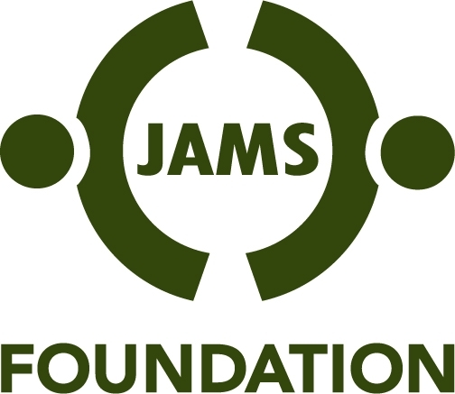

CALL FOR PROPOSALS
Conflict Resolution Training for School Teachers
Sponsored by the JAMS Foundation

Deadline for Receipt of Proposals: April 15, 2008
Submit to David Brandon via email: dbrandon@jamsfoundation.org

Background/Purpose:
There is a recognized and growing need to educate children in schools about conflict prevention, conflict management and conflict resolution. Conflict resolution education (CRE) is not part of most teacher education curriculums, nor is it standard in teacher certification requirements. Many CRE programs exist for use in schools, but they are underutilized. The JAMS Foundation has identified as a funding priority training teachers and school administrators in CRE.

Proposal Guidelines:
- It is anticipated that the teacher training to be funded will utilize existing conflict educational materials. Developing new CRE material and publications is not intended to be covered by this grant.
- Preference will be given to proposals that include a model for training trainers in order to reach a greater number of classroom teachers.
- Preference will be given to proposals that include building or expanding upon working relationships between university based teacher education programs, school districts and dispute resolution training organizations.
- Proposals from consortiums and partnerships are encouraged.
- It is anticipated that a proposed program will include at least two phases: The first phase will include pilot training programs in three or more cities in which JAMS Resolution Centers are located. (See www.jamsadr.com.) (Budget for Phase 1 not to exceed $250,000); Subsequent phases will expand the trainings to all cities in which there is a JAMS Resolution Center (Budget not to exceed $50,000 per site.)
- The training will be offered without charge to teachers and administrators and may include a small stipend for teachers who participate.
- Teacher training will include some type of follow-up or/and second round training.
- Proposals should include evaluation of the pilot phase to assess outcome effectiveness of the trainings.

Eligibility:
- The Foundation makes grants only to existing tax-exempt organizations with 501(c)(3) status from the Internal Revenue Service. The Foundation does not fund government entities, school districts, organizational overhead or indirect costs.

Requirements:
- Applicants please provide the following:
  - Clear description of the proposed training program and follow-up
  - Description of the existing CR training materials you intend to use
  - Information about how you will involve and work with university/college teacher education programs, school districts and dispute resolution training organizations
  - Detailed budget for each phase, not exceeding $250,000 for Phase 1, and $50,000 for each site thereafter
  - Indication of how the pilot phase will be evaluated for purposes of determining its success
  - Project timeline
  - Brief biography of program director or of leadership team members.

For more information, contact:

David Brandon, Program Manager
Email: dbrandon@jamsfoundation.org
Telephone: 415-774-2648
Mailing Address:
JAMS Foundation
Two Embarcadero Center, Suite 1500
San Francisco, CA 94111
www.jamsfoundation.org

